**© 2015 – Foxes Team**

[http://process.ws](http://foxes.info.vn)

**Defect Tracking Process**

**Foxes Project**

**Abstract**

The Defect Tracking Process defines activities in reporting defects discovered during testing workflow

**Table of Contents**

1. Introduction 3

1.1. Purpose 3

1.2. Scope 3

2. Defect Tracking Process Visual Diagram 4

3. Roles & Responsibilities 4

4. Process Activities 5

4.1. Create Defect 5

4.2. Review & Assign 5

4.3. Implement 6

4.4. Fixed and Ready for Test 7

4.5. Retest 7

4.6. Close 8

Revision 9

**Table of Figures**

Figure 1 - The overview of Testing Process 4

**Table of Tables**

Table 1 - Roles & Responsibilities of Testing Process 4, 5

Table 2 - Activities in Requirement Analysis step 7, 8

Table 3 - Activities in Test Estimation step 8

Table 4 - Activities in Test Plan Phase 9, 10

Table 5 - Activities in Test Analysis & Design Phase 10, 11

Table 6 - Activities in Test Execution Phase 12, 13

Table 7 - Activities in Test Report & Evaluation 13, 14

# Introduction

## Purpose

This document defines activities in reporting defects discovered during testing workflow. The goal of this document is to establish a standard communication protocol between Submitter and Implementer for reporting defects, maintaining and tracking them during the life of the project.

## Scope

* The Redmine system will be used to track not only the defects but also minor change requests so this document will give guidelines for defect tracking.
* The defect mentioned here is not only a software defect (injected in the source-code) that found by code review, testing but also a defect (injected in requirement document, design specs and test case) that detected by document reviews.
* All defects, including defects from documents, should be collected for causal analysis and resolution at the end of milestone or in regular basis.

# Defect Tracking Process Visual Diagram

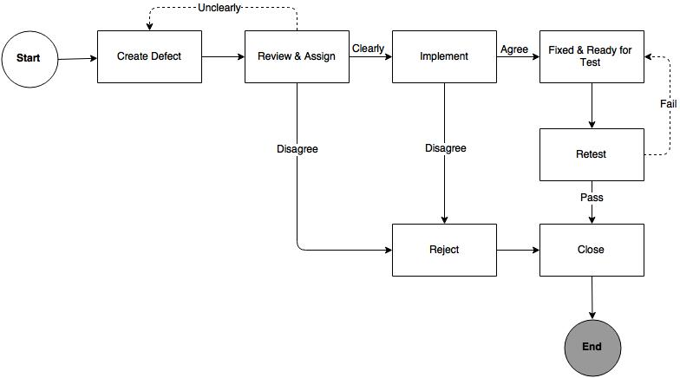

Figure - The overview of Defect Tracking Process

# Roles & Responsibilities

The following table describes participator who will be the participants of the defect tracking process in Foxes Project.

|  |  |  |
| --- | --- | --- |
| No. | Role | Responsibility |
| 1 | Submitter | The person who discovers the defect and submits it as such, usually the Tester. |
| 2 | Implementer | The person who implements the work product that has the defect, usually the Developer. |
| 3 | Test Lead | * The person who is ultimately responsible for the work product to be defect-free/error-free. * The person who will give the Stamp-of-Quality to the work product. |

Table 1 – Roles & Responsibilities of Defect Tracking Process

# Process Activities

## Create Defect

|  |  |
| --- | --- |
| Required Input | A defect is identified by Submitter. |
| Expected Output | A new issue is created in Redmine. |
| Participant | Submitter |
| This activity creates the description of defect found/error by Submitter during testing workflow.   * Collecting proofs (trace, logs, screenshots, documentation, other detailed information) of the defect. * Create a New Issue in Redmine.   The following Redmine fields to be updated:   * Tracker – Select “Defect” from pick up list * Subject – Short description for the issue * Description - Detailed description for the issue with the steps to reproduce… * Status – Select “Pending” from pick up list * Priority – Select “High/Normal/Low” from pick up list * Assignee – Test Lead * Environment – Select “Google Chrome/Mozilla Firefox/Internet Explorer” from pick up list * Version – Select the version of software * Bug Priority – Select “Minor/Major/Critical” from pick up list * Files – Import attachment file which describes for the defect | |

Table 3 – Create Defect Activity

## Review & Assign

|  |  |
| --- | --- |
| Required Input | An issue in Redmine with status is “Pending”. |
| Expected Output | A defect is reviewed and assigned to Implementer to fix. |
| Participant | Test Lead |
| This activity the Test Lead will review the defect which is created by Submitter.  If the defect is described in full, clear and precise, the Test Lead will assign to Implementer to fix (for Redmine with the current status is “Pending”)  The following Redmine fields to be updated:   * Assignee – Implementer   If the defect is described unclearly or missing information, the Test Lead can require Submitter provide more information.  The following Redmine fields to be updated:   * Assignee – Submitter   If the defect is not a defect, the Test Lead can “Rejected” and “Closed” for closing. | |

Table 4 – Assign Defect Activity

## Implement

|  |  |
| --- | --- |
| Required Input | A defect is assigned to Implementer in Redmine. |
| Expected Output | A defect is resolved or rejected. |
| Participant | Implementer |
| Implementer will analyze and evaluate the defect.   * Implementer changes status to “In Progress” to show he/she is in progress to analyze and fix the issue. * Implementer changes status to “Rejected” to show he/she reject and doesn't fix the issue. * Implementer changes status to “Postpone” to show he/she postpone and fix the issue in the future.   The following Redmine fields to be updated:   * Status – Select “In Progress/Rejected/Postpone” from pick up list | |

Table 5 – Implement Activity

## Fixed and Ready for Test

|  |  |
| --- | --- |
| Required Input | A defect is resolved by Implementer and ready for testing. |
| Expected Output | A defect after resolved is ready for test in Redmine. |
| Participant | Implementer, Test Lead, Submitter |
| This activity certifies that assigned implementer has been fixed his/her defect and it’s ready to be test.  The following Redmine fields to be updated:   * Status – Select “In Review” from pick up list   The Test Lead will assign the Submitter to retest the issue, which the issue has status as “In Review”.  The following Redmine fields to be updated:   * Assignee – Submitter | |

Table 8 – Fixed and Ready for Test Activity

## Retest

|  |  |
| --- | --- |
| Required Input | A defect is assigned to Submitter to retest and verified in Redmine. |
| Expected Output | Testing result for the defect.  Assign to Test Lead to close the defect. |
| Participant | Submitter |
| This activity certifies that the defect has been retested and passed all required cases.  The following Redmine fields to be updated:   * Comment – State whether the issue has been verified-passed or failed. * Assignee – Test Lead | |

Table 9 – Retest and Verified Activity

## Close

|  |  |
| --- | --- |
| Required Input | A defect after is retested by Submitter and assign to Test Lead. |
| Expected Output | Closing the defect. |
| Participant | Test Lead |
| This activity certifies that Test Lead has been closed defect.   * Test Lead will review Redmine and change to “Closed” when all required cases are met on all test environments. * The following Redmine fields to be updated:   + Status – Select “Closed” from pick up list   This activity certifies that Project lead has been closed defect when its status has been changed to the following status “Rejected”.   * For the defect with the “Rejected” status, assigned Implementer will provide more information in Redmine. Test Lead will review, confirm information of this Redmine and change to “Closed” when all required cases are met. * The following Redmine fields to be updated:   + Status – Select “Closed” from pick up list | |

Table 10 – Close Activity

# Revision

|  |  |  |  |
| --- | --- | --- | --- |
| # | Date | Editor | Description |
| **6** | Sep 09th, 2015 | Tỷ Trần | * + - Updating the Defect Tracking apply Redmine system. |
| **5** | Aug 18th, 2015 | Tỷ Trần | * Fixing Defect Tracking Process Visual Diagram after reviewed. |
| **4** | Aug 15th, 2015 | Tỷ Trần | * Adding Defect Tracking Process Visual Diagram. |
| **3** | Aug 14th, 2015 | Tỷ Trần | * Re-defining the Process Activities. |
| **2** | Aug 11th, 2015 | Tỷ Trần | * Updating Roles & Responsibilities. |
| **1** | Jul 30th, 2015 | Tỷ Trần | * Create Testing Process Draft Version. |